
Lab6 – Zoo!

CS1010
Points: 10

Propose:
In this lab, you will find a partner and write a complete modified version of a program completed in class. This lab helps you to practice While Loops in a program.

Instructions (Ask for guidance if necessary):
- To speed up the process, follow these steps.
  - Download the ###_###lastnamelab6.py onto your desktop (use your class codes for ### and your last name)
  - Launch Pyscripter and open the .py file from within Pyscripter.
  - Modified the code to solve the problem below.

- Modified the banner and add your class codes and names at the top as following:
#Name : ###YourLastName
#Name : ###YourLastName
- Add your code to complete program for the following program description:
The city zoo separates their animals according to weight. The locations are based on the weight cutoffs (in pounds) shown in the table below.
Weight | Location
200 or above | Jumbo Jungle
Less than 200 | Mid-Meadows

Complete the program that reads animal RFID (integer), Name (string) and Weight (integer) from a file called zoo.txt until the EOF is reached. The program will find the largest and smallest animal and calculate the average of each category. Add code where you see comments in the file. (hint: you will need a set of variables for each category)

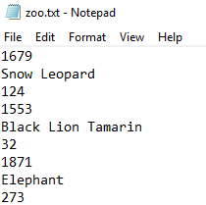
Data file Output Screen
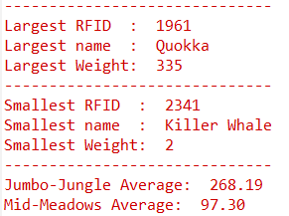

Input Note: The first data read in will be the RFID for the animal which means the name, which is read next can be read directly into the variable called name. You can do this with the following statement and strip off the \n without using the intermediate variable.

name = (infile.readline()).rstrip("\n")

Turn-in your program:
- Call me over once you are done to check your output.
- Early submission, you know what to do, include the output.

